


Maintain a paper-based filing and retrieval system
D1.HGE.CL7.03
D1.HGA.CL6.03
Trainee Manual






Maintain a paper-based filing and retrieval system

D1.HGE.CL7.03
D1.HGA.CL6.03

Trainee Manual





Project Base
William Angliss Institute of TAFE
555 La Trobe Street
Melbourne 3000 Victoria
Telephone: | (03) 9606 2111
Facsimile: | (03) 9670 1330
Acknowledgements
Project Director: | Wayne Crosbie
Chief Writer: | Alan Hickman
Subject Writer: | Nick Hyland
Project Manager/Editor: | Alan Maguire
DTP/Production: | Daniel Chee, Mai Vu, Kaly Quach

The Association of Southeast Asian Nations (ASEAN) was established on 8 August 1967. The Member States of the Association are Brunei Darussalam, Cambodia, Indonesia, Lao PDR, Malaysia, Myanmar, Philippines, Singapore, Thailand and Viet Nam.
The ASEAN Secretariat is based in Jakarta, Indonesia.
General Information on ASEAN appears online at the ASEAN Website: www.asean.org.
All text is produced by William Angliss Institute of TAFE for the ASEAN Project on “Toolbox Development for Front Office, Food and Beverage Services and Food Production Divisions”.
This publication is supported by the Australian Government’s aid program through the ASEAN-Australia Development Cooperation Program Phase II (AADCP II).
Copyright: Association of Southeast Asian Nations (ASEAN) 2013.
All rights reserved.
Disclaimer
Every effort has been made to ensure that this publication is free from errors or omissions. However, you should conduct your own enquiries and seek professional advice before relying on any fact, statement or matter contained in this book. The ASEAN Secretariat and William Angliss Institute of TAFE are not responsible for any injury, loss or damage as a result of material included or omitted from this course. Information in this module is current at the time of publication. Time of publication is indicated in the date stamp at the bottom of each page.
Some images appearing in this resource have been purchased from stock photography suppliers Shutterstock and iStockphoto and other third party copyright owners and as such are non-transferable and non-exclusive. Clip arts, font images and illustrations used are from the Microsoft Office Clip Art and Media Library. Some images have been provided by and are the property of William Angliss Institute.
Additional images have been sourced from Flickr and SXC and are used under Creative Commons licence: http://creativecommons.org/licenses/by/2.0/deed.en
File name: TM_Maintain_a_paper-based_filing_&_retrieval_syst_refined.docx





Table of contents
Introduction to trainee manual 1
Unit descriptor 3
Assessment matrix 5
Glossary 7
Element 1: Maintain information systems 9
Element 2: Retrieve files in response to information requests 21
Element 3: Maintain existing recording and filing systems 31
Presentation of written work 51
Recommended reading 53
Trainee evaluation sheet 55
Trainee self-assessment checklist 57

Introduction to trainee manual

To the Trainee
Congratulations on joining this course. This Trainee Manual is one part of a ‘toolbox’ which is a resource provided to trainees, trainers and assessors to help you become competent in various areas of your work.
The ‘toolbox’ consists of three elements:
- A Trainee Manual for you to read and study at home or in class
- A Trainer Guide with Power Point slides to help your Trainer explain the content of the training material and provide class activities to help with practice
- An Assessment Manual which provides your Assessor with oral and written questions and other assessment tasks to establish whether or not you have achieved competency.
The first thing you may notice is that this training program and the information you find in the Trainee Manual seems different to the textbooks you have used previously. This is because the method of instruction and examination is different. The method used is called Competency based training (CBT) and Competency based assessment (CBA). CBT and CBA is the training and assessment system chosen by ASEAN (Association of South-East Asian Nations) to train people to work in the tourism and hospitality industry throughout all the ASEAN member states.
What is the CBT and CBA system and why has it been adopted by ASEAN?
CBT is a way of training that concentrates on what a worker can do or is required to do at work. The aim is of the training is to enable trainees to perform tasks and duties at a standard expected by employers. CBT seeks to develop the skills, knowledge and attitudes (or recognise the ones the trainee already possesses) to achieve the required competency standard. ASEAN has adopted the CBT/CBA training system as it is able to produce the type of worker that industry is looking for and this therefore increases trainees chances of obtaining employment.
CBA involves collecting evidence and making a judgement of the extent to which a worker can perform his/her duties at the required competency standard. Where a trainee can already demonstrate a degree of competency, either due to prior training or work experience, a process of ‘Recognition of Prior Learning’ (RPL) is available to trainees to recognise this. Please speak to your trainer about RPL if you think this applies to you.
What is a competency standard?
Competency standards are descriptions of the skills and knowledge required to perform a task or activity at the level of a required standard.
242 competency standards for the tourism and hospitality industries throughout the ASEAN region have been developed to cover all the knowledge, skills and attitudes required to work in the following occupational areas:
- Housekeeping
- Food Production
- Food and Beverage Service
- Front Office
- Travel Agencies
- Tour Operations.
All of these competency standards are available for you to look at. In fact you will find a summary of each one at the beginning of each Trainee Manual under the heading ‘Unit Descriptor’. The unit descriptor describes the content of the unit you will be studying in the Trainee Manual and provides a table of contents which are divided up into ‘Elements’ and ‘Performance Criteria”. An element is a description of one aspect of what has to be achieved in the workplace. The ‘Performance Criteria’ below each element details the level of performance that needs to be demonstrated to be declared competent.
There are other components of the competency standard:
- Unit Title: statement about what is to be done in the workplace
- Unit Number: unique number identifying the particular competency
- Nominal hours: number of classroom or practical hours usually needed to complete the competency. We call them ‘nominal’ hours because they can vary e.g. sometimes it will take an individual less time to complete a unit of competency because he/she has prior knowledge or work experience in that area.
The final heading you will see before you start reading the Trainee Manual is the ‘Assessment Matrix’. Competency based assessment requires trainees to be assessed in at least 2 – 3 different ways, one of which must be practical. This section outlines three ways assessment can be carried out and includes work projects, written questions and oral questions. The matrix is designed to show you which performance criteria will be assessed and how they will be assessed. Your trainer and/or assessor may also use other assessment methods including ‘Observation Checklist’ and ‘Third Party Statement’. An observation checklist is a way of recording how you perform at work and a third party statement is a statement by a supervisor or employer about the degree of competence they believe you have achieved. This can be based on observing your workplace performance, inspecting your work or gaining feedback from fellow workers.
Your trainer and/or assessor may use other methods to assess you such as:
- Journals
- Oral presentations
- Role plays
- Log books
- Group projects
- Practical demonstrations.
Remember your trainer is there to help you succeed and become competent. Please feel free to ask him or her for more explanation of what you have just read and of what is expected from you and best wishes for your future studies and future career in tourism and hospitality.

Unit descriptor
Maintain a paper-based filing and retrieval system
This unit deals with the skills and knowledge required to Maintain a paper-based filing and retrieval system in a range of settings within the hotel and travel industries workplace context.
Unit Code:
D1.HGE.CL7.03
D1.HGA.CL6.03
Nominal Hours:
20

Element 1: Maintain information systems
Performance Criteria
1.1 Maintain information and filing systems in accordance with organisational requirements
1.2 Identify, remove and/or relocate inactive or dead files in accordance with organisational requirements
1.3 Establish and assemble new files in accordance with organisational requirements
1.4 Update reference and index systems in accordance with organisational requirements

Element 2: Retrieve files in response to information requests
Performance Criteria
2.1 Locate specified files/records within designated timelines
2.2 Retrieve relevant file
2.3 Record movements of documentation according to enterprise policies and procedures
2.4 Follow security and confidentiality procedures

Element 3: Maintain existing recording and filing systems
Performance Criteria
3.1 Maintain recording and filing systems according to enterprise policies and procedures
3.2 Allocate new documents to designated category
3.3 Monitor the issue and return of documents to ensure the integrity of the system is maintained
3.4 Archive, remove and update documents to ensure appropriate space available for current records
3.5 Identify and locate required files and dispatch to nominated person or section within designated time limits
3.6 Monitor and record file and document movements
3.7 Maintain documents in good condition and in correct location
3.8 Separate confidential files from general files, with access available to nominated personnel only
3.9 Monitor security system to ensure issued files are traceable at all times

Assessment matrix
Showing mapping of Performance Criteria against Work Projects, Written Questions and Oral Questions
The Assessment Matrix indicates three of the most common assessment activities your Assessor may use to assess your understanding of the content of this manual and your performance – Work Projects, Written Questions and Oral Questions. It also indicates where you can find the subject content related to these assessment activities in the Trainee Manual (i.e. under which element or performance criteria). As explained in the Introduction, however, the assessors are free to choose which assessment activities are most suitable to best capture evidence of competency as they deem appropriate for individual students.
 |  |  | Work Projects | Written Questions | Oral Questions
Element 1: Maintain information systems
1.1 | Maintain information and filing systems in accordance with organisational requirements |  | 1.1 | 1, 2 | 1
1.2 | Identify, remove and/or relocate inactive or dead files in accordance with organisational requirements |  | 1.2 | 3 | 2
1.3 | Establish and assemble new files in accordance with organisational requirements |  | 1.3 | 4 | 3
1.4 | Update reference and index systems in accordance with organisational requirements |  | 1.4 | 5 | 4
Element 2: Retrieve files in response to information requests
2.1 |  | Locate specified files/records within designated timelines | 2.1 | 6 | 5
2.2 |  | Retrieve relevant file | 2.2 | 7 | 6
2.3 |  | Record movements of documentation according to enterprise policies and procedures | 2.3 | 8 | 7
2.4 |  | Follow security and confidentiality procedures | 2.4 | 9, 10 | 8
Element 3: Maintain existing recording and filing systems
3.1 | Maintain recording and filing systems according to enterprise policies and procedures |  | 3.1 | 11 | 9
3.2 | Allocate new documents to designated category |  | 3.2 | 12 | 10
3.3 | Monitor the issue and return of documents to ensure the integrity of the system is maintained |  | 3.3 | 13 | 11
3.4 | Archive, remove and update documents to ensure appropriate space available for current records |  | 3.4 | 14 | 12
3.5 | Identify and locate required files and dispatch to nominated person or section within designated time limits |  | 3.5 | 15 | 13
3.6 | Monitor and record file and document movements |  | 3.6 | 16 | 14
3.7 | Maintain documents in good condition and in correct location |  | 3.7 | 17, 18 | 15
3.8 | Separate confidential files from general files, with access available to nominated personnel only |  | 3.8 | 19 | 16
3.9 | Monitor security system to ensure issued files are traceable at all times |  | 3.9 | 20 | 17

Glossary
Term | Explanation
Alphabetical | Places files in order from A through to Z
Archive | To place or store documents or records in an archive.
Binder | A detachable cover, resembling the cover of a notebook or book, with clasps or rings for holding loose papers together
Confidentiality | Spoken, written, acted on, etc., in strict privacy or secrecy; secret
Chronological | Sorting records according to their date
Dispatch | To send in a prompt and speedy manner
Document | A written or printed paper furnishing information or evidence. any written item, as a book, article, or letter, especially of a factual or informative nature
File | A collection of documents
File categories | Documents of a similar nature or ‘category’
Filing system | A method or equipment used to store files in a logical and organised format
Folder | A folded sheet of light cardboard used to cover or hold papers, letters, etc., as in a file
Geographical | Physical location
Hard copy documents | Documents prepared on paper. Not in electronic format.
Inactive file | A file that is not in use at this time
Personnel | Staff members of an organisation
Record Management | The management of hard copy documents and files
Source documents | A source document is evidence of a transaction

Element 1:
Maintain information systems

1.1 Maintain information and filing systems in accordance with organisational requirements

Introduction

Whilst technology is having a greater impact in the way we conduct business activities including the production, transfer and storage of information, there will always be a need to maintain hard copy information.
Lots of hard copy documents produced within a hospitality organisation business will need to be filed or stored.
Whilst there may a legal reason to retain hard copy documents, in many cases the retention of documents will be a preference of the organisation itself.
This information may be kept as a form of evidence to support or back up electronic documents or may be primary method of recording information.
One of the main benefits of maintaining hard copy documents is that they are not affected by technological viruses or electrical problems that may arise. Hard copies of documents may not be very ‘high tech’ but it is amazing how valuable they become when the hard drive crashes, or there is a power or other failure and the data from the hard or other drive is unavailable.
Therefore appropriate storage and filing of hard copies of computer generated documents is a common and vital occurrence.
In many cases a hard copy of data may be taken and filed or archived for future use. While hard copies cannot be readily amended unless retyped into the computer, or scanned in, they at least provide a source document for future reference.

Importance of having a good filing system
Filing means keeping documents in a safe place and being able to find them easily and quickly. Documents that are cared for will not easily tear, get lost or dirty.
A filing system is the central record-keeping system for a hospitality organisation. It helps the department and individual team members to be organised, systematic, efficient and transparent. It also helps all people, regardless of departments, who should be able to access information to do so easily.
It is always a pleasure when someone looks for something and is able to find it without difficulties. In many hospitality establishments we work in groups, whether departmental or functional. We receive and send out documents on different subjects. We need to keep these documents for future reference. If these documents are not cared for, we cannot account for all our organisational activities. Everyone who needs to use documents should know where to get them.

Importance of filing and storing hard copy documents
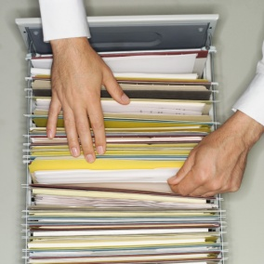
Most hard copy documents sent out by an establishment will be copied or the original will be filed.
This is because it is a good idea to have a copy of the document for future reference. In case of a query, a dispute, or perhaps for use when doing a further quote, providing additional service or tendering.
Documentation may also be filed as a legal requirement. This may include registration cards, which indicate who stayed in what room, when and for how long.
Guest accounts and credit card vouchers (establishment copy) are also filed in case of discrepancies, or queries to the charges.
Once a document has been created, edited, information checked, printed out and a copy taken of it, it will then be filed.
Most offices will have a filing cabinet. This is the most common filing system.

Personnel handing hard copy documentation
All manner of personnel is required to handle hard copy documentation.
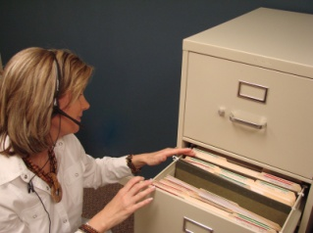
For some, it may be a key aspect of their job; for example, those working in an office environment. For others it may be an occasional task, including those working in a stock control environment or a kitchen.
All personnel at all levels would apply this skill, but it does describe a basic operational function of minimal complexity.
Different properties will have different needs for office documents although there is bound to be some degree of sameness across the industry.
This manual identifies the processes that are involved with documentation, and the types of documentation that may be found in hospitality office environments.
As part of their daily duties, hotel receptionists and certain other staff will have to process and maintain hard copy documents in accordance with enterprise procedures and within required timelines.

Types of hard copy information
Whilst each organisation will have different types and uses of hard copy information, it may include:

- Correspondence, such as faxes, memos, letters, email and other documents
- Computer databases, such as library catalogue, customer records
- Sales records, including monthly forecasts, targets achieved
- Forms, including insurance forms, membership forms
- Invoices, such as from suppliers, to debtors
- Personnel records, including personal details, salary rates
- Information on training needs
- Marketing reports/plans/budgets
- Financial figures – see below
- Production targets.

Financial source documents
One major type of hard copy information is source documents used in recording financial information.
Whilst many financial records used to record and identify revenue and expenses may be prepared through electronic spreadsheets and reports, in many cases the maintenance of hard copy source documents is a must.
A source document is simply a starting point. Just as a garden begins with a seed, a financial system begins with a source document.
A source document is evidence of a transaction.
For example, a receipt is evidence that you have paid an account; obtaining the guest’s signature on an internal docket is proof they have received the products and services listed.
Every financial transaction must have a corresponding source document as evidence that the transaction actually took place.
Examples of source documents include:
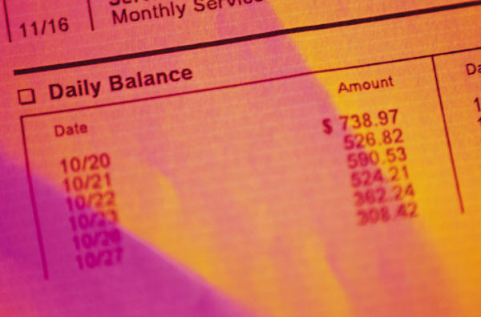
- Cheques – as proof that an account was paid
- Deposit books – as evidence that money and other non-cash deposits were paid into the bank
- Cheque requisitions – as proof that you requested payment of an account for a certain amount on the date stated
- Tax invoices – as proof you either bought the items listed when they are issued to you, and you sold the items listed when you issue them to a customer
- Credit notes – are proof that you have returned items to suppliers for credit when they are issued to you, and you have received back items from customers when you issue them to a customer
- Expense vouchers – are proof the authorised signatory has used the items listed in some approved way such as buying a drink for a customer
- Petty cash vouchers – as proof of minor amounts of money spent by approved staff on behalf of the organisation
- Bank statements – as proof of deposits made and cheques written.
A poor source document will result in poor financial records so it is important source documents capture, provide and record the information necessary for the maintenance of accurate and complete financial records.
Most source documents have their name printed on them – Purchase Order, Requisition, Voucher, Credit Note or Tax Invoice.
For example, a Tax Invoice or Purchase Order should contain:

- Date of the transaction
- Name of the person or business making the purchase
- Name of the business supplying the goods and services
- A reference number for follow-up, identification and cross-referencing purposes
- Full description of what was supplied or ordered including:
A Credit Note would contain similar information, usually be written in red and describe the items that have been returned for credit.
The more information your source document has, the more accurate your financial records will be.
Many internal source documents require an approved signature before they are valid.

Types of organisational requirements
As can be seen above, there are many examples of hard copy documents that may be kept in a hospitality organisation. Given that many of these documents are not only of a sensitive nature, but need to be stored in a logical and easy to locate manner, each organisation is likely to have a number of requirements that must be followed when handling them.
These organisational requirements may include:
- Security and confidentiality requirements
- Legal and organizational policy/guidelines and requirements
- Management and accountability channels

- Code of Conduct/Code of Ethics
- Procedures for updating records
- Information protocols
- Who has responsibility for producing and handling documents
- Who has authority for authorising documents and signing them prior to despatch
- Filing and storing copies of documents
- Identification of (blank and pro forma) documents that need to be prepared on a regular basis – such as rosters, management reports.

1.2 Identify, remove and/or relocate inactive or dead files in accordance with organisational requirements

Introduction
In today’s world, the storage of documents is not a major concern given that electronic devices can store endless amounts of electronic information and documents.
In situations where hard copy documents are concerned, most organisations will have an allocated space designated for its filing and storage. Once these spaces have been filled, documents that are not of further use or relevance must be discarded in accordance with organisational procedures.

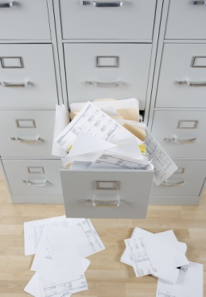
Types of inactive or dead files
Inactive or dead files may include:
- Completed projects or events
- Old clients
- Paid accounts
- Ex employee information.

Removing files
Like in any situation, most document storage areas must remain clean, streamlined and free from excess and unused paper.
Therefore any inactive files must be removed or relocated in a timely and appropriate manner.
In some situations, due to legal requirements files must be retained for a predetermined period of time. In these cases, whilst they cannot be destroyed they can be kept in locations that are not used on a frequent basis or will slow daily operations.
This may include relocating files to an external storage facility or a central head office.


Destroying files
Where files need to be destroyed, they must be done in a manner that ensures that the information contained within cannot be accessed or copied by others.
In many cases these documents may be shredded.

1.3 Establish and assemble new files in accordance with organisational requirements

Introduction
As mentioned in this manual to date, having an easy to use and functional filing system is important to help maximise efficiency.

Solicit input from users
It is important that end users have the opportunity to have input into how files will be established.
When establishing and assembling new files it is important that the end user understands:
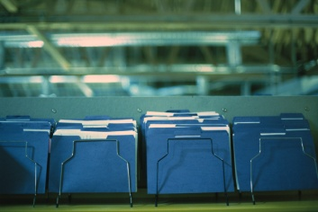
- How files will be filed
- Methods of identifying files
- Where they will be located
- How they can be accessed.

Establishing file categories
To make a filing system more effective it is essential to group files into ‘categories’. A category is a group/collection of files or documents that belong together.
Whilst different hospitality departments and individual positions will have their own categories, they will undoubtedly have documents of a similar nature or ‘category’
As an example, a banquet organiser may have the following categories, in their filing system:
- Enquiries
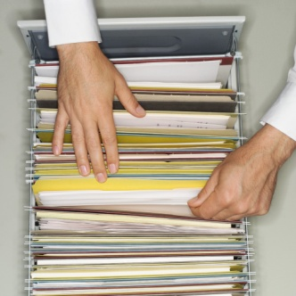
- Tentative reservations
- Confirmed events
- Supplier information
- Regular corporate clients
- Past clients information
- Invoices
- Menus
- Photos.
When we file by categories, we try to file in a logical way; we put files together because they belong together; we don't put them together just because they start with the same letter.
For example, we could put all our files into categories. ‘Supplier information’ could be one category that takes up a whole drawer of our filing cabinet. Inside that drawer we could have sub-categories. Sub categories could be things like:

- Florists
- Photographers
- Transportation
- Catering
- Audio – visual equipment
- Theming.

Forming categories
Some easy to follow suggestions include:
- Sort all your documents out into piles that you think belong together
- Give each pile a category name
- Make a list of categories
- Look at your list critically:
- Can we combine any categories?
- Should we break up a category into two categories?
- What sub-categories do we need?
- Do we need to have alphabetical files within a category?
Make sure you don't have too many categories. It should not be difficult for anyone to decide in which category they are likely to find the information they need.
The next section will explore different referencing and index systems that can be used.

Filing procedure
Whilst each organisation will have their own system for filing documents, a common and popular system has been identified below.

Step 1: Receiving the document
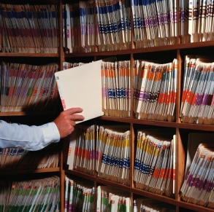
If it is a letter or document that came through the mail, you record it in the "mail received" register and write the date received or date stamp it.

Step 2: Action
Forward the letter/document to the person that has to deal with it.

Step 3: Follow up
Check that the letter has been dealt with.

Step 4: Collecting Documents to be filed
All documents and two copies of the replies must be collected in a filing tray.

Step 5: Filing
Choose a regular time to file every day so that you are never left with a huge pile of loose documents. Use a sorter to help you file and remember to file by date order.

Easily identifiable files and folders
Don't create new files unless you are absolutely sure the information does not logically fit into an existing file. Put the new file in the correct category and write it in the filing key immediately. Give everyone a copy of the new categories as soon as possible.
It is recommend that each new file is given a name that is clear, makes sense and is easy to locate.
There should be, if possible, no ‘miscellaneous’ files.
If you are unsure of a folder or category name for a file, put it under the first category you think of when considering the document or again, solicit suggestions from potential end users.


File documents immediately
When you have a new item to be filed, create the file right away. Have necessary folders and writing tools available near your filing system, so this process can be done quickly and smoothly. You don’t want to create a ‘build up’ of files on your desk.
Where possible arrange documents and notes within a file in a logical order before storing. It is a good idea to staple pages together instead of using paper clips so pages are kept in their correct order and to avoid pages going missing.

Consistency amongst filing systems
Each department will have their own files and systems, tailored to their own needs. Whilst there will be differences and different types of files and information to be stored, where possible, when there are multiple filing systems in the hospitality establishment, have everyone establish the same or similar type of filing system.

1.4 Update reference and index systems in accordance with organisational requirements


Introduction
As the number and types of documents you produce grows and changes, and as the requirements of the business alters, so, too, is there a need for the reference and index systems to be modified and updated to reflect those changes.

Role of the reference and index systems
Implementing a reference and index system enables you to file and then readily access paper-based documents.
In some properties, it is common to store hard copy for electronic copies in a paper-based file, too.
The system used may reflect the general filing system. That is, it may simply be a system that indexes files in alphabetical order.
There may be subsections to the index – such as a section for suppliers, a section for quotes, a section for employees, and a section for customers, etc.
The index can be as simple as a book that records documents/letters, etc. and their location or it can be a complex coded-system.
Identification tags are placed onto individual hanging folders, and the folder is then placed in alphabetical order.

Types of reference and index systems

Traditionally, companies have been focused on updating their physical records. It is important to take the time and get the resources to get this right, in accordance with industry and enterprise practices.
Reference and index systems may relate to:
- Alphabetic
- Numeric
- Alpha-numeric
- Topic
- Subject.
The different ways to categorise information will be detailed in Section 3.2

Work Projects
It is a requirement of this Unit you complete Work Projects as advised by your Trainer. You must submit documentation, suitable evidence or other relevant proof of completion of the project to your Trainer by the agreed date.
  - To fulfil the requirements of this Work Project you are asked to identify the importance of having filing systems and different information stored within these systems.
1.2. To fulfil the requirements of this Work Project you are asked to identify how to identify, remove and/or relocate inactive or dead files.
1.3. To fulfil the requirements of this Work Project you are asked to identify how to set up new files and categories.
1.4. To fulfil the requirements of this Work Project you are asked to identify the importance of having reference and index sections.

Summary

Maintain information systems
Information and filing systems are maintained in accordance with organizational requirements
Importance of having a good filing system
Importance of filing and storing hard copy documents
Personnel handing hard copy documentation
Types of hard copy information
Financial source documents
Types of organisational requirements.
Inactive or dead files are identified, removed and/or relocated in accordance with organizational requirements
Types of inactive or dead files
Removing files
Destroying files.
New files are established and assembled in accordance with organizational requirements
Solicit input from users
Establishing file categories
Forming categories
Filing procedure
Easily identifiable files and folders
File documents immediately
Consistency amongst filing systems.
Reference and index systems are updated in accordance with organizational requirements
Role of the reference and index systems
Types of reference and index systems.

Element 2:
Retrieve files in response to information requests

2.1 Locate specified files/records within designated timelines


Introduction
One of the main priorities of using a filing system is to ensure that files and documents can be located, identified and retrieved in a timely and efficient manner.
By having a reference and index system as identified in Section 1.4 helps ensure that this is possible.
In addition, it is essential that not only the files and documents themselves are filed in a logical order, but the storage area itself is set out and labelled in a logical layout.

Finding information
Keeping information in files is only useful if we, and everyone in our organisation, knows how to find the documents we need. We file information so that we can find it easily. Finding information that is in the files is called retrieving information.
Everyone who needs to use the files should be able to find information quickly and easily. This means that they must know the method of filing we use.

Filing method book
A filing method book could be a small book that we use to explain how we file documents. For example:
- All letters are filed under correspondence
- All membership cards are filed under number
- Reports are filed by subject.
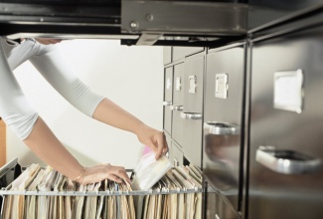
An index book can also help us to find files. The name of each file can be written on the page with that letter. For example:
- The MINUTES file is written on the M page. Then we can write where that file is
- "MINUTES - filing cabinet 1 drawer 2 or lever arch file 4".

Types of hospitality files and documents
In section 1.1 of this manual, a range of hard copy documents have been identified. These mainly relate to general office environments. Whilst these files apply to any office structure, hospitality organisations may also need to handle, process, file and store other documents including:

- Guest mail – incoming and outgoing, domestic and international, normal post or special delivery requirements: most accommodation properties offer guests this service – stamps, insurance, priority payments, costs for satchels, etc. are charged-back to their room and the account settled on departure
- Customer records – internal files such as guest history, profile, accounts, folios, and internal charges documents and vouchers need to be processed constantly. Electronic systems reduce some of the requirements in this area, but there is always a need to process any hard copy documents that the guest actually signs to verify receipt of goods/service – these hard copy documents continue to provide ‘proof of purchase’ where the customer queries a charge even in an electronic environment

- Incoming and outgoing correspondence relating to the operation of the establishment – this can include sending out quotations, sending out accounts for payment, responding to requests from various individuals, groups and organisations about the property, especially booking queries and complying with various governmental requirements
- Files – these can be paper-based or electronic and include correspondence, advertising, guest-related, advanced bookings (restaurant, accommodation, functions) as well as a range of files established by management to facilitate the operation of the business and tracking of its actual performance
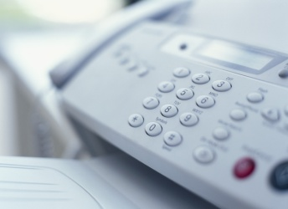
- Letters – in response to queries, complaints and congratulations, plus others as requested by management: some letters may be form letters while others will be unique in nature
- Facsimiles (faxes) – as above. You may be required to prepare general distribution faxes, or draft specific draft responses to nominated faxes. The use of faxes seems to be declining in favour of e-mails for instant communication, but they nonetheless continue to be an important communication tool for business and an important vehicle for both receiving and sending some documents
- Memos – internal memos from various departments and managers. Processing can include producing the memo as well as distributing it as required. A pro forma is used with the specific contents varying according to need
- Reports – this can involve working in conjunction with the night auditor, or the production of monthly operational reports, or one-off proposals for action
- Menus – for all areas of the venue including function menus, and room service menus
- Banquet orders – for forwarding to the relevant suppliers and distributing to relevant internal departments who are involved with the banquet/function

- Financial records – as determined by management
- Invoices – sent out by the venue requiring payment for goods and services supplied by the property
- Receipts – acknowledging receival of payment for goods and services rendered, or for advanced deposits forwarded by guests, conference holders, tour operators and function organisers.

Types of paper based filing systems
There are a number of ways in which hard copy information may be stored. These include:
Filing cabinets | 3-drawer, 4-drawer, 2-drawer
Flat Boxes | Flat box file, horizontal plan file
Lever arches | Binder
Suspension folders | Hanging files
Shelving | Lateral cabinets, compactus
Other | Trolley, spike file, rotary file, concertina file

2.2 Retrieve relevant file

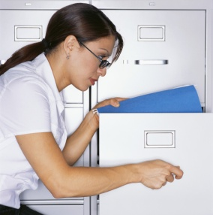
Introduction
Once the specific file has been found, it is time to retrieve it. In many cases files have been kept for a specific reason. It is therefore important that is files are removed for whatever reason, that there is a written record of this removal.
In many cases, any file removed must be returned to the original file for later use by others.
At times, more than one person may need access to a specific file. By having a sufficient recording system in place, this helps to ensure that if a file is not in its original location, it is easy to see who currently has it.

Ensuring files are not lost
When people take files out of the filing system, or they take documents out of a file, we must ensure that they don't lose them or forget to bring them back. People must never take the suspension files out, they should only take out the flat folder inside the file.
To keep track of files we need a record of all the files or document that people borrow.


File Out Book
A file-out book is simply a book in which we write:
- Who borrowed the file or document
- Name of the file or document
- When they borrowed it
- When they returned it.
Example:
Name of File | Category | Person with file | Date taken out | Date returned
Hyland Wedding Running Sheet | Weddings | P Smith | 18 March 2013 | 20 March 2013
Seminar Photos | Photos | R Kelly | 20 March 2013
The person responsible for maintaining the system can us the file-out book to check who has which files an remind them to return it.

File Out Card
File-out cards are used in a filing cabinet. They are the same size as the files and are put in the place of the file, which has been borrowed.
On the file-out card we write the same information as in the book, i.e.
- Who borrowed the file or document
- Name of the file or document
- When they borrowed it
- When they returned it.

2.3 Record movements of documentation according to enterprise policies and procedures

Introduction
When documents are physically removed and transferred to another location, depending on the type and importance of document, a paper trail may be used to record the movements of the files.
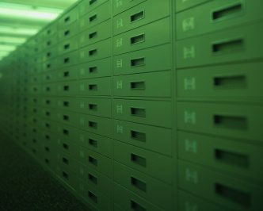
This helps to identify:
- Who has the physical document
- Who issues or authorised the movement of the document
- Where the document is currently located.
This is particularly important in locations which contain vast amounts of physical files or a wide range of storage locations.

Types of document movements
There are endless types of movements involving documents including:
- Recording incoming or outgoing documents including mail, packages, accounts, reports, faxes and e-mails – there may be separate Mail In and Mail Out books that need to be completed: these detail incoming and outgoing mail by addressee, date received/sent. Where guest mail is sent on behalf of the guest there will also be a need to record the costs involved so these can be recouped from the guest

- Filing including electronic filing of correspondence, guest and reservation details, brochures and price lists, catalogues and personal contact details for guests, staff, suppliers, support industries, emergency services, service industries, tourist attractions and bodies, government bodies and local authorities
- Mailing including bulk mailing for the establishment and on behalf of guests, and picking up mail from post boxes. The people who produce the documents are often responsible for making sure those documents are forwarded, sent, distributed, etc. Bulk mail situations will occur, for example, where members of a Loyalty Club or similar are sent a newsletter, a special offer, or an update

- Photocopying – for staff, departments, management and guests, and then adding copies to relevant files
- Faxing – for staff, departments, management and guests. There may be a need to complete a Fax Register that records the faxes that were sent (who to, time, content, confirmation of ‘sent fax’) and the faxes that were received
- E-mailing – in response to incoming requests from guests and potential guests, travel agencies, tour wholesalers, airlines, coach companies, and other accommodation facilities: e-mails are becoming an increasingly popular way for clients to contact the property and either make enquiries or lodge bookings. Any property that offers online facilities must make sure these facilities are constantly monitored so that appropriate and timely responses can be made
- Binding and distribution of monthly and annual reports, training notes, discussion papers, marketing strategies and in-house minuted.

Ways to record movements
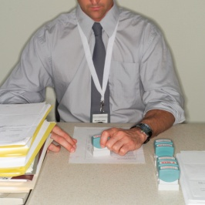
In the last section, a number or recording systems have been identified.
Some other ways to record movements may include:
- Updating file register
- Updating records management system
- Temporary or permanent transfer of records.


Benefits of recording document movements
There are many benefits resulting from the recording of document movements. These are:
- Establishes a transparent record of who has the document and where it has gone
- Requires authorisation to receive documents
- Easy to see who has received and had the opportunity to read documents – this helps when following up on information
- Records the time and date in which a specific person has physically received a document – this may be beneficial for legal purposes as actual proof a person has viewed or been give the document.

2.4 Follow security and confidentiality procedures

Introduction

Many hard copy files and documents contain information of a sensitive and confidential nature. It is essential that this information is protected in a manner that ensures that only authorised persons have access to them.
This may be ensured through physical protection of documents such as locked storage areas or various policies and procedures relating to the handling, distribution and discussion of documents themselves or information contained within.

Types of confidential and sensitive information
Information that may be considered confidential or sensitive may include:
- Personal information relating to both personnel and guests
- Credit card information

- Salary and benefits entitled to personnel
- Personnel performance appraisal information
- Complaints
- Claims of harassment or discrimination
- Financial information
- Strategic information
- Notes left by clients at a conference
- Notes left by guests in hotel rooms.

Importance of security
Security of documents on file is important and must be ensured to:

- Protect the confidential nature of business documents – this means keeping business documents private, and maintaining the confidentiality of guest/customer details
- Provide back-up information in the case of computer crash – or if there is another dramatic event in the business such as a fire. In this case, continuity of the business is an essential requirement and many risk management plans will address the specific needs of documentation and records when preparing a risk management plan for the establishment
- Provide hard copy evidence of bookings received, monies received and accounts that have been paid.
Standard practices for offices are to back up all computer files daily/weekly in order to minimise loss in the event of a problem.
Where computer files are backed up to an external drive there is usually also a requirement that this back-up external drive be stored at a specific off-site location so that, in the event of fire, robbery, etc., it is not lost along with the computer system in the workplace.

Types of security and confidentiality procedures

Security and confidentiality procedures may include:
- Access authority
- Lockable files/cabinets
- Confidentiality.
These security and confidentiality procedures will be discussed in more detail later in the manual.

Work Projects
It is a requirement of this Unit you complete Work Projects as advised by your Trainer. You must submit documentation, suitable evidence or other relevant proof of completion of the project to your Trainer by the agreed date.
2.1 To fulfil the requirements of this Work Project you are asked to identify types of paper based filing systems.
2.2. To fulfil the requirements of this Work Project you are asked to identify steps associated with receiving files.
2.3. To fulfil the requirements of this Work Project you are asked to identify how to record movement of documents.
2.4. To fulfil the requirements of this Work Project you are asked to identify types of security and confidentiality systems used to protect documents and the information contained within.

Summary

Retrieve files in response to information requests
Locate specified files/records within designated timelines
Finding information
Types of hospitality files and documents
Types of paper based filing systems.
Retrieve relevant file
Ensuring files are not lost.
Record movements of documentation according to enterprise policies and procedures
Types of document movements
Ways to record movements
Benefits of recording document movements.
Follow security and confidentiality procedures
Types of confidential and sensitive information
Importance of security
Types of security and confidentiality procedures.

Element 3:
Maintain existing recording and filing systems

3.1 Maintain recording and filing systems according to enterprise policies and procedures


Introduction
Some documentation is kept on file because the establishment has identified a potential need for it.
It is therefore important to maintain, modify and update whatever reference systems the establishment has decided to keep.
This means ensuring the information contained within reports is current and accurate as much as possible.
Hard copy reservations & bookings
All bookings (hard copy) are filed based on an arrival date system: booking information is filed in the current month and in date order 1–31.

If the current month is October and the guest arrives on the 24th of October, then the booking would be filed under this date. However if the booking is for the 2nd of November, then the bookings will be filed under November.
At the end of the day, the night auditor or other designated staff member may place all documentation in a Day Box. The day box may be labelled with the date and then placed in a larger box, which may be called the Monthly Box. At the end of the month, this box will be clearly labelled with the appropriate month and the year.

The box is then placed in the archives and kept on file for at least six years (a legal requirement). If there are any queries, for instance, by a guest who stayed at the hotel three months ago, we can retrieve the monthly box from the archives and go through the daily box to find the account in question.
Legally required information
It is also a legal requirement to keep certain files in storage in case an individual needs to be located because of a criminal or civil law action, which may include:
- An insurance claim being lodged
- A theft from the guest’s room
- A fire in the hotel.
The taxation department requires business records to be kept for five years, but some businesses archive their records for seven years as standard practice.
Operational reports
Other documentation that may need to be modified and updated may include:
- Arrival and departure reports
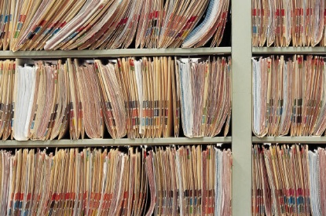
- Revenue reports
- In-house activity reports
- Staff timesheets
- Work claim forms
- Accident reports
- Staff rosters.
Each department will have their own information and hard copy documents that need to be updated, filed and stored according to their operational needs and any legal requirements.

3.2 Allocate new documents to designated category

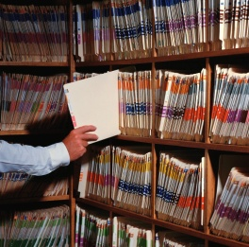
Introduction
In section 1.4, the importance of using some sort of reference or index system was explained. Depending on the nature of the information being stored, it is important that established and easy to identify categories within these index systems are implemented.
This section explores some of the most common categories used to identify, separate and store information.
Techniques to organise information
The most common types of classification for records and information are alphabetic, numeric, alpha-numeric, geographic, subject, keyword and chronological.

Alphabetical
The most commonly used method of filing, the alphabetical system, place files in alphabetical order according to the customer or business name e.g. the telephone book. There are a number of rules to remember when using the alphabetic system:
- Disregard ‘joining’ words and titles such as “and”, “the”, “&”, “Mr”, “Sir”, “Dr”, “Miss” etc.
- Hyphenated or compound names are treated as one word e.g. Jones-Smythe and van der Lynden are both indexed as one word

- Initials come before names (in filing “nothing comes before something”), e.g. B. Thompson would be filed ahead of Brian Thompson
- Company names are treated in the order they are written, except if they contain a family name e.g. both Grace Bros and Robert E. Grace & Sons are filed under „Grace‟, but Robert & Hickey would be filed under ‘Robert’
- Abbreviations are treated as if the word was written in full
- St. is indexed as Saint, Ltd. as Limited. This means that St. and Saint entries are treated as if spelt the same way, as are Mac and Mc
- Numbers which are part of a business or company name are regarded as though spelled e.g. 24-7 is indexed as twenty-four seven.

Numerical
Each file or piece of information is filed in number order, from lowest to highest, according to the number on the document (for example, invoice number) or the customer number.

Geographical
Information is indexed alphabetically according to geographical location. States/Provinces are indexed first, followed by the city, town or suburb, then other appropriate information e.g. customer name.

Subject
Records are sorted according to the subject matter and filed alphabetically. This allows information on the one topic, or subject, to be easily located.

Key word
A particular word is used as the subject classification and specific descriptors are also allocated to further classify the information. Keyword systems are usually used in large organisations where the keywords are specifically designated.

Chronological

Chronological filing is used in conjunction with other filing methods and involves sorting records according to their date.
This is commonly used when storing reservation information, identified either through check-in or check out date. It is also used to store original receipts relating to restaurant and bar.
In a client file for example, correspondence would be filed with most recent on top. Copies of Purchase Orders would be filed with the most recently sent order on top.

Colour Coding
Some premises use a colour-coding system to differentiate between files and documents. The system may be based on:
- A specific colour per department
- A specific colour per staff member
- A specific colour per month or year
- A specific colour for the different categories of customers that we have – such as retail business customers, VIPs, travel agents, tour operators
- A specific colour for the nature of the file – for example:
- Quotations – green folder
- Complaints – red folder
- General correspondence – purple folder.

3.3 Monitor the issue and return of documents to ensure the integrity of the system is maintained

Introduction

Files are kept in specific locations for the benefit of all staff, to help them conduct day to day activities. It is therefore important that staff has access to these files when required.
If files go missing, not only does this make it inconvenient for other staff seeking information, it may also have serious confidential concerns if lost.
Management must place a priority to monitor that any files issued have been returned, in a complete format.
This is not done to punish people or because of mistrust of staff, it is simply to ensure all staff have access to files when they need them.

Recording movement of files
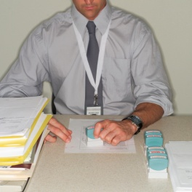
As previously mentioned, it is important to have a recorded record of files that have been issued to personnel. By having this record not only can you see if files have been returned, but also who currently has them (if the file itself is missing) or has had them (if content within the file is missing or to discuss in further detail).
In Section 2.2 of this manual a number of methods used to record the movement of documents have been identified including the:
- File Out Book
- File Out Card.

Check recording systems and files
Not only is it important to have recording mechanisms in place, they must also be managed.

Therefore management should ensure that all personnel are aware that the use and return of files is considered to be of an important nature and that the movement of files is carefully managed.
This can be achieved by:
- Ensuring the above mentioned recording systems are: checked on a regular basis
- Following up outstanding files with relevant persons
- Conducting a ‘stock take’ of files where possible
- Remind staff of the importance of returning files to original locations.

3.4 Archive, remove and update documents to ensure appropriate space available for current records


Introduction
Where files or documents pass a certain time such as 12 months after their date, they may be removed and stored in a secure location for a nominated time. This is usually 5–7 years.
This called ‘archiving’.
Removing designated inactive files
Periodically, files may need to be culled or archived.
These files are commonly known as ‘inactive files’.
Clearing the inactive files frees up more space for current or active files and reduces the number of unnecessary files that have to be contended with when performing filing tasks.
This is where files are not being regularly used. Perhaps the customer has not dealt with us in twelve months, or it is a supplier whom we no longer deal with. There may be a need to update these files as follows:
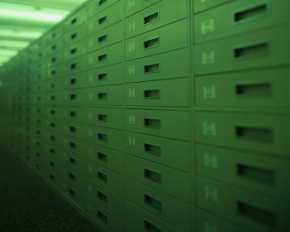
- Physically work through the files and remove anything older than a certain time – the exact time will depend on your business but 12 months is a good guide
- Where the material is to be thrown out, it is common business practice to shred anything that is remotely likely to be personal or confidential in nature. An alternative is to engage the services of a business that specialises in the bulk removal of ‘security’ documents. They supply a locked bin/container and remove the it on a regular basis and destroy the contents on your behalf, for a fee
- Documents may need to be archived – this may be a legal requirement for some papers (especially tax-related ones), or it may be part of a contractual requirement with a certain customer. The archive can simply be archive boxes kept somewhere on the premises or elsewhere. These boxes have a list attached to the outside of them detailing what is contained inside.
It is a sound idea to physically work through all paper-based files that are due to be culled or archived in order to satisfy yourself that no important items are being ‘processed’ that need to be held on to, or which have inadvertently found their way into the wrong file.
This can be a very time-consuming job and usually needs to be undertaken over a number of weeks and may require assistance from others.
Note, however, help from others is pointless and arguably a waste of time and money if they don’t know what they have to be on the lookout for, or if they are continually needing to ask you ‘is this important or not?’

Methods to archive
Archive may refer to:
- Handling completed/closed files in accordance with the organization’s policy, procedure and system
- Storing confidential files in an internal/external repository
- Being able to retrieve archived files from storage, when required.
Off-site storage
Storage of source documentation/information off-site may be done in larger properties and is usually done with information that is no longer current.
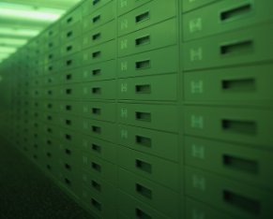
The information is ‘archived’ off-site in a secure location such as head office, a lock-up facility or a lockable transport/shipping container for future reference if required.
These archived documents and files are usually stored in numbered or otherwise identifiable boxes. To facilitate file retrieval, a list or computer file is generated to show what documents and files have been archived in which box.

3.5 Identify and locate required files and dispatch to nominated person or section within designated time limits

Introduction
At times personnel within the hospitality organisation will seek information or access to files that may be in your possession.
It is normal procedure for files to be distributed to others. Each organisation will have their own policies and procedures for transporting hard copy files to other personnel.
When transporting files, the security of the files themselves and the information contained within must be maintained.

Issuing files to others

When issuing files to others it is important that you ensure:
- These files can easily be identified
- The persons seeking the files have the authority to be given them
- The files are given to them in a timely manner
- They are informed that files must be recorded or signed for
- Files are returned if applicable.

Methods to issue files to others
There are a number of ways in which to issue files to others, depending on a number of factors including:
- Practicality of sending documents
- Urgency of document to be delivered
- Size of documents or files
- Level of confidentiality or security required
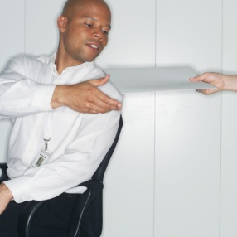
- Cost of delivery.
Methods of issuing files include:
- Hand to hand
- Use of a courier
- By mail
- By registered mail
- Electronically by scanning and emailing or faxing.

3.6 Monitor and record file and document movements

Introduction

In previous sections various ways to monitor and record file and document movements have been identified.
This section will explore in more detail examples of Record Management Guidelines that can be amended to suit the requirements of each hospitality organisation.
These guidelines cover a wide range of issues relating to the filing, handling and management or records.

Example of Record Management Guidelines
The following is a sample ‘Records Management’ for an hard copy system.
‘Printed copies of this form are uncontrolled. Current version located in Outlook/Public Folders/Policies, Procedures & Guidelines Folder Authorised by: Chief Executive Officer 12 September 2012.

Purpose
These guidelines aim to ensure correspondence is appropriately listed in the hard copy filing system according to the organisational classification system.
The official title given to all files should be classified using the organisational classification system and should enable a summary or concise statement of the contents of the file to be made.
Using the classification system and limiting the use of acronyms, abbreviations and punctuation will subsequently aid in the successful retrieval of all files when requested.

Scope
These guidelines apply to the management of all XYZ files.

3. Procedure
3.1 XYZ classification system structure
The classification system created for XYZ represents its current business functions and associated activities. All business functions and activities are represented by a unique code that acts as the file number.
Example of classification system: Below is an example of the classification system being used to create a new file and how the file number is subsequently created.
Finance & Accounting – Budgets/Estimates – Records Management Budget
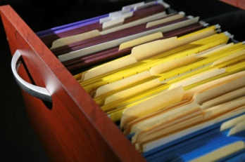
Keyword Descriptor Free Text Title
The keyword represents the business function. In this case, the file being created relates to the business function of Finance and Accounting.
Only one keyword can be used for each file created. The file code for Finance and Accounting is represented by FI.
Descriptors are terms which breakdown the keyword into more specific subject areas.
Descriptors are often known as the activities of the business function.
The descriptor used for this file is Budgets and Estimates and its file code is 03.
The title must act as a summary or concise statement of the contents of the file. It must explain the type of correspondence contained within the file.
The file code for the free text title is a computer-generated sequential number. In this case, the number is 0001.
The file number for the above file is FI/03/0001.
If another Finance & Accounting – Budgets/Estimates file was created, the file number would be FI/03/0002.
3.2 Using the classification system to create new files
For a new file to be created there must be correspondence generated internally or received externally which requires registration onto the records management system.
If a new file needs to be created, determine the activity or subject of the correspondence.
Consult the classification system and determine the correct keyword and descriptor for classification.
3.3 Free text titles
The free text title must act as a summary or concise statement of the contents of the file.
It must explain the type of correspondence contained within the file.
How to create a free text title for a file
Read correspondence to determine the subject or activity being addressed.
Type a concise statement to summarise the data. If possible, also provide a date, being the date the file contents date back to, i.e., file commenced March 2010.
Include key subject words for easy searching and retrieval.
3.4 Words not to be used in free text titles
Words such as ‘general’ or ‘miscellaneous’ should never be used in titles, as they do not allow effective searching and retrieval of information.
If the word correspondence is to be used in a title, then the type of correspondence must be explained in detail.
3.5 Language controls
The use of acronyms, abbreviations and punctuation must be controlled to ensure effective searching and retrieval of information is maintained.
Acronyms used within the organisation must be typed in full, and if necessary, the acronym may be typed in brackets after the full name, for example:
Property Management – Operations – Gilded Swan Banquet Room (GSBR).
Human Resources – Management – Enterprise Bargaining Agreement (EBA) – Stage Two.
3.6 Abbreviations and punctuation
To maintain the integrity of the information captured into the organisational recordkeeping system, the use of abbreviations and punctuation must be controlled.
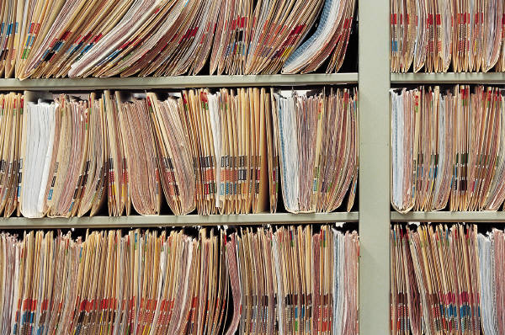
Abbreviations can be used if the word is not considered to be a vital term when performing a search for information.
For example:
- Management (MGMT)
- And (&)
- Restaurant (REST).
When punctuation is used such as full stops, brackets and back and front slashes, a space between the punctuation and the word must be evident.
If there are no spaces between the word and the punctuation used then searching will be hampered, for example:
- Records Management Budget 2010 / 2011
- Tourism Council Australia (TCA) – National
- Entertainment Survey Results July – December 2010.
4. Responsibility
Records Administrator – accountable for the content and review of these procedures.
5. Definitions
Classification – is the process whereby records are categorised or grouped into units of similar business functions.’
Importance of Record Management Guidelines
As can be seen, a records management system helps to identify and explain the steps taken to accurately record and file hardcopy files for easy retrieval.

3.7 Maintain documents in good condition and in correct location

Introduction
Given that hard copy files are in fact physical pieces of information, it is essential that these files are looked after and kept in good working condition as much as possible.
In many organisations, the best way to preserve documents is to scan and save electronic versions of files, but this is not always possible, especially where large volumes of documents are produced or where original versions with original signatures are required.
Maintaining the filing system
One of the most important reasons why we file is to keep document safe. It is therefore very important to make sure that all papers and files are kept in good condition. Here are some ways that we can do this:
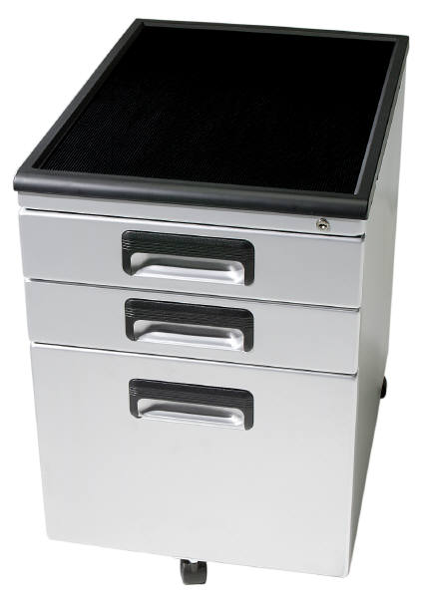
- Keep documents that are waiting to be filed in trays, do not leave them lying about on desks or shelves.
- File documents away at least once a day, or if your organisation is very small you can do it once a week
- Do not put too much in files or folders
- Put new covers on old files which get a lot of use and have become worn or torn
- Box files and lever arch files can hold more than simple folders
- Never allow filing drawers or shelves to become too full. Acquire new filing cabinets when necessary.
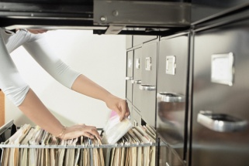
Good housekeeping and safety
At the end of every day you should:
- File all the documents you can
- Put away those you cannot file in filing trays
- Lock up all confidential documents
- Place all waste paper in rubbish bins
- Leave desks tidy.

3.8 Separate confidential files from general files, with access available to nominated personnel only

Introduction
Confidentiality is a set of rules or a promise that limits access or places restrictions on certain types of information.
Most hard copy files in a hospitality operation, whilst they may contain some ‘confidential’ information, can be viewed and are often used by different levels of staff and management across various departments.

Types of general files

These files are considered to be ‘general’ and contain information that helps to clarify and address operational needs including:
- Expected arrivals and departures
- Timing of banqueting activities
- Expected VIP’s
- Staff movements
- Updated information or facts
- Explanation of in-house promotions or menus.
In relation to the distribution and access to general files, the priority is to make them as accessible as possible to all staff to ensure they have updated and accurate information.
They may be copied, distributed, explained during meetings and briefings or placed on noticeboards.
Whilst most information may be for general consumption, there is still a certain amount of information that is ‘confidential’ in nature and can only be viewed by a select number of persons.
This information must be handled in a discrete yet secure manner.

Types of confidential files
As mentioned in Section 2.4 of this manual, confidential files may include:
- Staff personnel files
- Financial information
- Operational information
- Commercial in confidence.
Whilst these have been touched on in previous sections, they will be explained in more detail.
Staff personnel files
Staff files often relate to:
- Personnel files relating to staff members themselves
- Staffing procedures that are undertaken during the course of employment.
Generally these files will be kept by the Human Resources Department and are available to a limited amount of management. They should however be available to the individual staff members themselves, at their request.
In many cases, whilst the information contained inside may not appear to be ‘confidential’ given that it is personal information, most staff members would not feel comfortable that the information is shared, especially that relating to salary or medical information.
Personnel files

- Current employees in alphabetical order
- Personal information
- Testimonials
- Job applications
- Banking Details
- Medical information.
Staff Procedures
- Personnel Procedures
- Conditions of Employment

- Contract of Employment
- Salary Information
- Induction
- Job descriptions
- Performance Appraisals
- Staff Training
- Leave.
Financial information
In many organisations the distribution and discussion of financial matters is quite open and available to all that seek it. It is the cornerstone and focus of most managerial activities and the key discussion points of most management meetings.
That said, whilst financial information may be readily discussed and distributed within a hospitality organisation, companies will not allow this information to be shared with external interests, especially competitors.
An on-going task when maintaining financial records is to file all source documents in the correct location and in accordance with any specific enterprise requirements.
Keeping documents secure will require all relevant paperwork to be filed in some way that facilitates easy access and retrieval of documents.
A common method of keeping these documents is in a lockable filing cabinets, arranged in some generic order (in-line with the naming of the journals used or by similar classifications such as ‘Invoices’, ‘Credit Notes’) and then by either ‘alphabetical’ or ‘date’ order.
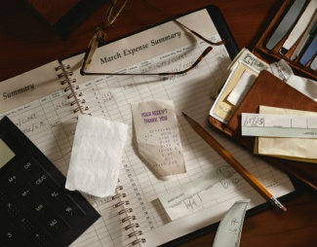
Books – as opposed to individual and loose-leaf documents – such as Order/Purchase Books will be kept intact (as they contain a duplicate or triplicate of the actual order) and simply stored on a shelf, in a carton or in a drawer with the relevant dates written large on the outside cover.
The task of filing these documents may be delegated to a junior staff member but it must be remembered that this filing process is an important function and needs to be completed as accurately as posting the actual transactions.
Types of financial information
- Budget

- Salaries
- Financial Statements
- Petty Cash
- Auditor's Statements
- Tax
- Strategies
- Bank
- Debtors
- Bookkeeping.

Operational information
Each department will have operational information, normally in the form of reports that contains sensitive information, which should only be used for internal operational matters.
For example, various operational reports used by the Front Office department include:

Arrivals Report/Arrivals List
This is an alphabetical listing of guests arriving on a specific day.
Departures Report/Departures List
This is an alphabetical listing of guests departing on a specific day.
No Show Report
This is a list of guests who have made a booking but did not show on the day.
Room Status Report
This is a list giving the status of every guest room – vacant clean room ready, vacant dirty or out of order.
Special Requests Report
This is a list of guests requesting something special in their room prior to their arrival – cot, champagne, fruit basket.
Occupancy Forecast Report
This is usually printed for a month (the next 30 days).
This list is an indication of the occupancy percentage expected for the next month. This forecast will change according to additional bookings and cancellations.

Average Room Rates Report
This indicates total room revenue in one day divided by the number of rooms occupied to establish the average room rate.
Multiple or Double Room Occupancy Report
This report specifies how many rooms in the establishment had more than one guest in the room.
Guest List by Name Report
This is an alphabetical list of all ‘in-house’ guests.
Guest List by Room Report
This is a list of all occupied rooms – starting from the lowest room number to the highest, followed by a guest name.
Travel Agents’ Commission Report
Travel agents are usually entitled to a 10% commission (or some other negotiated percentage) on all accommodation bookings made via their agency.
This report outlines the amounts the establishment owes to a specific travel agent.
Failure to pay the correct commission and pay it promptly may result in that agency referring people to another property.
Special Packages Report
This report details how many packages – and what sort – the establishment has sold for a specific period.
Market Segment Report
This report displays what market the establishment is attracting, such as corporate, industry, family, coach, group, etc.
Rooms Out of Order Report
This report lists all rooms that are out of order, the reason for their being ‘off the board’ and the duration the room will remain in this status.
Daily Room Revenue Summary Report

This report lists the total room revenue for a specific day.
Daily Revenue Summary Report
This report outlines establishment revenue for a specific day broken down into departments such as food and beverage, accommodation, functions, room service, etc.
Weekly Trading Summary Report
This report outlines the total establishment revenue based on a weekly period, and may compare it to the same week last year.
Monthly Trading Summary
This report outlines the total establishment revenue based on a monthly period, and may compare it to the same month last year.
Year-to-Date Report
This report lists cumulative establishment revenue for a 12-month period.
In-house Activity Report
This is a comprehensive report outlining:
- Rooms occupied

- Expected departures
- Expected stay overs
- Expected arrivals
- Walk ins
- No shows
- Rooms available
- Occupancy %
- F.O.C. (Free Of Charge) rooms

- Out of order rooms
- Single occupancy rooms
- Multiple occupancy rooms.
Commercial in confidence
There are also other types of information that are commonly not for public viewing.
Some of these include, but certainly not limited to:
- Ownership Agreements

- Management Agreements
- Trademark information
- Strategic information
- Contracts
- Recipes
- Business proposals.
Authorised access
Privacy issues and the need to keep information confidential have always been very big issues in any hospitality organisation.
It is therefore critical only authorised personnel have access to these documents as they will contain details of a sensitive nature.
It is important that an authorisation system, including the physical distribution of documents and access to filing cabinets is established.
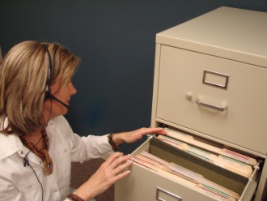
Other security considerations include:
- Keep office doors locked from the inside to protect against entry by unauthorised staff and members of the public
- Don’t leave paperwork, documentation and records lying around where they may be visible to others
- Keep ‘private’ and ‘confidential’ files locked.

3.9 Monitor security system to ensure issued files are traceable at all times

Introduction
In this manual, we have explored a number of ways in which to keep track of files.

One of the best ways to ensure files are tracked is to have a dedicated person who is responsible for the monitoring and tracing of files.
Methods to trace and secure files
This person might be required to:
- Check file movement recording documentation
- Follow up with staff deemed to have files at regular intervals to list on a file census form all the files held by that person. This form may be signed by both parties that the document is still in the possession of the staff member
- Keep a centralised record of file movements
- Conduct a physical stock take of files in specific locations – this is not feasible for all files but may be an important requirement for highly confidentially or sensitive documents

- Issue and sign in important documents at the start and end of shift
- Ask security to conduct locker or bag searches where highly sensitive information is not permitted to leave the premises.
In essence, some of these security measures are not practical or required, but the concept of keeping track of the location of documents is extremely important.
If each and every staff member is able to take responsibility for files in their possession and keeping a streamlined procedure for file management, it is a great start.

Work Projects
It is a requirement of this Unit you complete Work Projects as advised by your Trainer. You must submit documentation, suitable evidence or other relevant proof of completion of the project to your Trainer by the agreed date.
3.1 To fulfil the requirements of this Work Project you are asked to identify legally required information that must be maintained in a hospitality establishment.
3.2. To fulfil the requirements of this Work Project you are asked to identify techniques used to allocate new documents to designated categories.
3.3. To fulfil the requirements of this Work Project you are asked to identify how to monitor the issue and return of documents.
3.4. To fulfil the requirements of this Work Project you are asked to identify how to archive, remove and update documents.
3.5 To fulfil the requirements of this Work Project you are asked to identify how to issue files to other persons.
3.6 To fulfil the requirements of this Work Project you are asked to identify topics contained with ‘Record Management Guidelines’.
3.7 To fulfil the requirements of this Work Project you are asked to identify how to maintain documents in good condition and in their correct location.
3.8 To fulfil the requirements of this Work Project you are asked to identify examples of confidential files and general files.
3.9 To fulfil the requirements of this Work Project you are asked to identify how to ensure issued files are traceable.

Summary

Maintain existing recording and filing systems
Maintain recording and filing systems according to enterprise policies and procedures
Hard copy reservations & bookings
Legally required information
Operational reports.
Allocate new documents to designated category
Techniques to organise information.
Monitor the issue and return of documents to ensure the integrity of the system is maintained
Recording movement of files
Check recording systems and files.
Archive, remove and update documents to ensure appropriate space available for current records
Removing designated inactive files
Methods to archive
Off-site storage.
Identify and locate required files and dispatch to nominated person or section within designated time limits
Issuing files to others
Methods to issue files to others.
Monitor and record file and document movements
Example of Record Management Guidelines
Importance of Record Management Guidelines.
Maintain documents in good condition and in correct location
Maintaining the filing system
Good housekeeping and safety.
Separate confidential files from general files, with access available to nominated personnel only
Types of general files
Types of confidential files
Staff personnel files
Financial information
Operational information
Commercial in confidence
Authorised access.
Monitor security system to ensure issued files are traceable at all times
Methods to trace and secure files.

Presentation of written work

1. Introduction
It is important for students to present carefully prepared written work. Written presentation in industry must be professional in appearance and accurate in content. If students develop good writing skills whilst studying, they are able to easily transfer those skills to the workplace.

2. Style

Students should write in a style that is simple and concise. Short sentences and paragraphs are easier to read and understand. It helps to write a plan and at least one draft of the written work so that the final product will be well organized. The points presented will then follow a logical sequence and be relevant. Students should frequently refer to the question asked, to keep ‘on track’. Teachers recognize and are critical of work that does not answer the question, or is ‘padded’ with irrelevant material. In summary, remember to:
- Plan ahead
- Be clear and concise
- Answer the question
- Proofread the final draft.

3. Presenting Written Work
Types of written work
Students may be asked to write:
- Short and long reports
- Essays
- Records of interviews
- Questionnaires
- Business letters
- Resumes.
Format
All written work should be presented on A4 paper, single-sided with a left-hand margin. If work is word-processed, one-and-a-half or double spacing should be used. Handwritten work must be legible and should also be well spaced to allow for ease of reading. New paragraphs should not be indented but should be separated by a space. Pages must be numbered. If headings are also to be numbered, students should use a logical and sequential system of numbering.
Cover Sheet
All written work should be submitted with a cover sheet stapled to the front that contains:
- The student’s name and student number
- The name of the class/unit
- The due date of the work
- The title of the work
- The teacher’s name
- A signed declaration that the work does not involve plagiarism.
Keeping a Copy
Students must keep a copy of the written work in case it is lost. This rarely happens but it can be disastrous if a copy has not been kept.
Inclusive language
This means language that includes every section of the population. For instance, if a student were to write ‘A nurse is responsible for the patients in her care at all times’ it would be implying that all nurses are female and would be excluding male nurses.
Examples of appropriate language are shown on the right:
Mankind | Humankind
Barman/maid | Bar attendant
Host/hostess | Host
Waiter/waitress | Waiter or waiting staff

Recommended reading
Aslett, Don; 2008 (2nd edition); The Office Clutter Cure; Adams Media
Felton, Sandra; 2011 (1st edition); Smart Office Organizing: Simple Strategies for Bringing Order to Your Workspace; Revell
Jaderstron, Susan; 2002 (3rd edition); Complete Office Handbook; Random House Reference
Ricci, Monica; 2005 (1st edition); Organize Your Office In No Time; Que Publishing
Additional reading sourced from ‘Trove: National Library of Australia’ at http://trove.nla.gov.au/.
Bosworth, Seymour & Kabay, Michel E & Whyne, Eric, 1981- 2014, Computer security handbook, Sixth edition, Hoboken, New Jersey John Wiley & Sons, Inc
Gaskin, Shelley & Vargas, Alicia & McLellan, Carolyn 2014, Go! with Microsoft office 2013, Boston Pearson
Hawkins, Lisa 2014, Digital life: computer concepts projects, Boston Pearson
Holcombe, Jane & Holcombe, Charles, (author.) 2014, Survey of operating systems, Fourth Edition, New York, NY McGraw-Hill
Hoffer, Jeffrey A & Ramesh, V. (Venkataraman) & Topi, Heikki 2014, Essentials of database management, Boston Pearson
Lind, Douglas A & Marchal, William G & Wathen, Samuel Adam 2015, Statistical techniques in business & economics, Sixteenth edition, New York, NY McGraw-Hill Education
Parsons, June Jamrich & Oja, Dan, (author.) 2014, New perspectives, computer concepts, 2014, Comprehensive, [16th edition], Boston, MA Course Technology.

Trainee evaluation sheet

Maintain a paper-based filing and retrieval system
The following statements are about the competency you have just completed.
Please tick the appropriate box | Agree | Don’t Know | Do Not Agree | Does Not Apply
There was too much in this competency to cover without rushing.
Most of the competency seemed relevant to me.
The competency was at the right level for me.
I got enough help from my trainer.
The amount of activities was sufficient.
The competency allowed me to use my own initiative.
My training was well-organized.
My trainer had time to answer my questions.
I understood how I was going to be assessed.
I was given enough time to practice.
My trainer feedback was useful.
Enough equipment was available and it worked well.
The activities were too hard for me.
The best things about this unit were:

The worst things about this unit were:

The things you should change in this unit are:

Trainee self-assessment checklist
As an indicator to your Trainer/Assessor of your readiness for assessment in this unit please complete the following and hand to your Trainer/Assessor.

Maintain a paper-based filing and retrieval system
 |  | Yes | No*
Element 1: Maintain information systems
1.1 | Maintain information and filing systems in accordance with organisational requirements
1.2 | Identify, remove and/or relocate inactive or dead files in accordance with organisational requirements
1.3 | Establish and assemble new files in accordance with organisational requirements
1.4 | Update reference and index systems in accordance with organisational requirements
Element 2: Retrieve files in response to information requests
2.1 | Locate specified files/records within designated timelines
2.2 | Retrieve relevant file
2.3 | Record movements of documentation according to enterprise policies and procedures
2.4 | Follow security and confidentiality procedures
Element 3: Maintain existing recording and filing systems
3.1 | Maintain recording and filing systems according to enterprise policies and procedures
3.2 | Allocate new documents to designated category
3.3 | Monitor the issue and return of documents to ensure the integrity of the system is maintained
3.4 | Archive, remove and update documents to ensure appropriate space available for current records
3.5 | Identify and locate required files and dispatch to nominated person or section within designated time limits
3.6 | Monitor and record file and document movements
3.7 | Maintain documents in good condition and in correct location
3.8 | Separate confidential files from general files, with access available to nominated personnel only
3.9 | Monitor security system to ensure issued files are traceable at all times

Statement by Trainee:
I believe I am ready to be assessed on the following as indicated above:
Signed: _____________________________ | Date: ____________

Note:
For all boxes where a No* is ticked, please provide details of the extra steps or work you need to do to become ready for assessment.





